**Team Safe Neighborhood**

**(Gael G / Lori B / Sisay T / Sujita K / Van S)**

For Project 2, Team 4 (Team Safe Neighborhood) has chosen to analyze and visualize Crime data in the DFW metroplex.

The purpose of this exercise is to check the relationship between home values and or income and crime rate in DFW area.

Open data sources will be used for the data. The sites that will be used are the data.texas.gov, Zillow and Dallas Open Data sources.

Below are the links to the data sources:

<http://www.city-data.com/nbmaps/neigh-Dallas-Texas.html>

<http://www.dallasopendata.com/>

<https://www.dallasopendata.com/dataset/Dallas-Crimes/pumt-d92b>

Below are a couple of screenshots of our metadata.

**Crime Data**

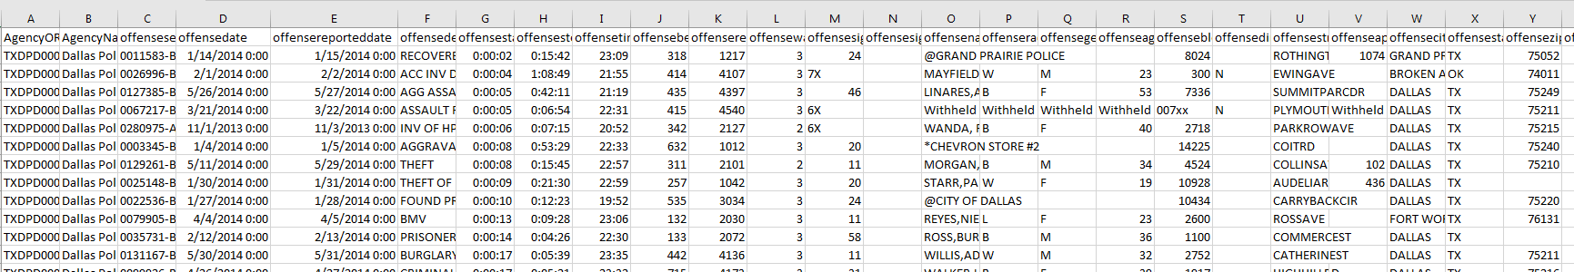

**Home Values**

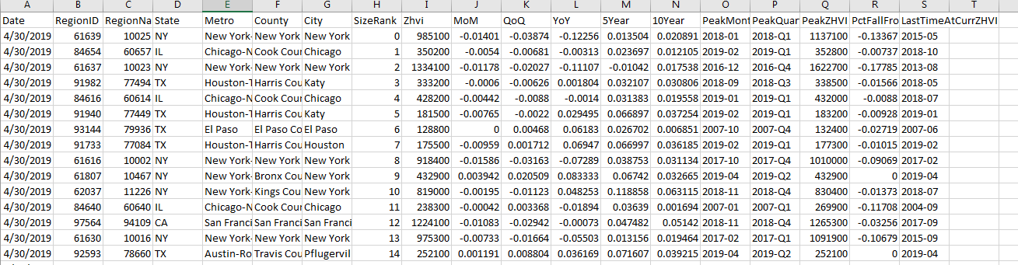

The first set of data will contain crimes in the DFW metroplex. The data will be filtered for offence types related to burglary, robbery and theft. This is because, we want to find the correlation between crime and household income and / or crime and average home price at a certain location.

The two data sets will then be combined to create a map that shows concentration of crimes in different cities.

Below are some examples of visualizations we hope to simulate for DFW.

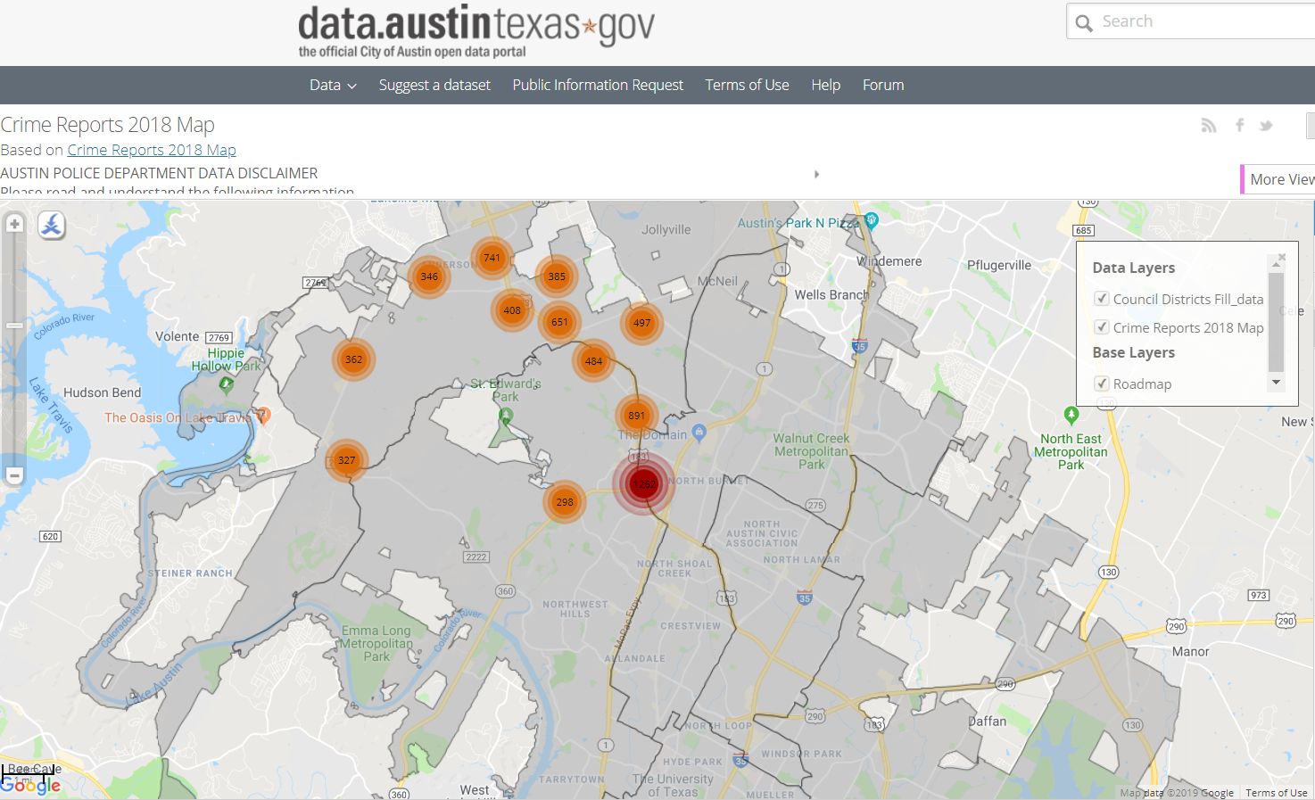

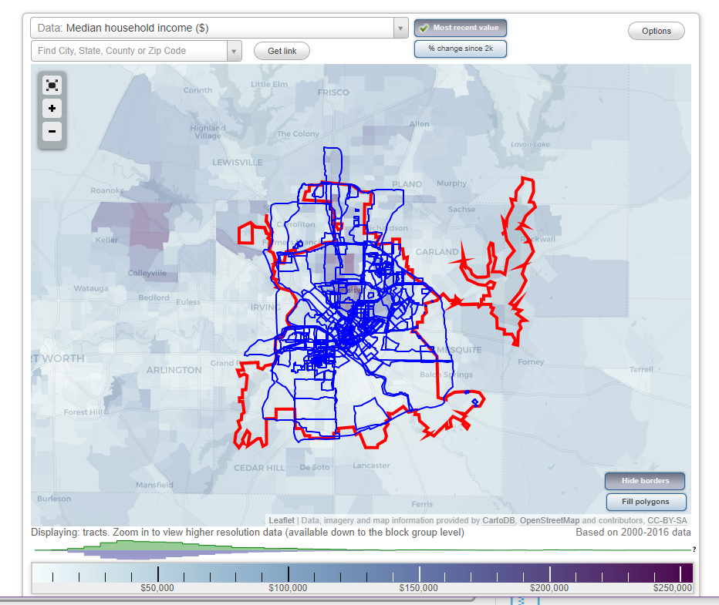

Below is the sketch of our final report.

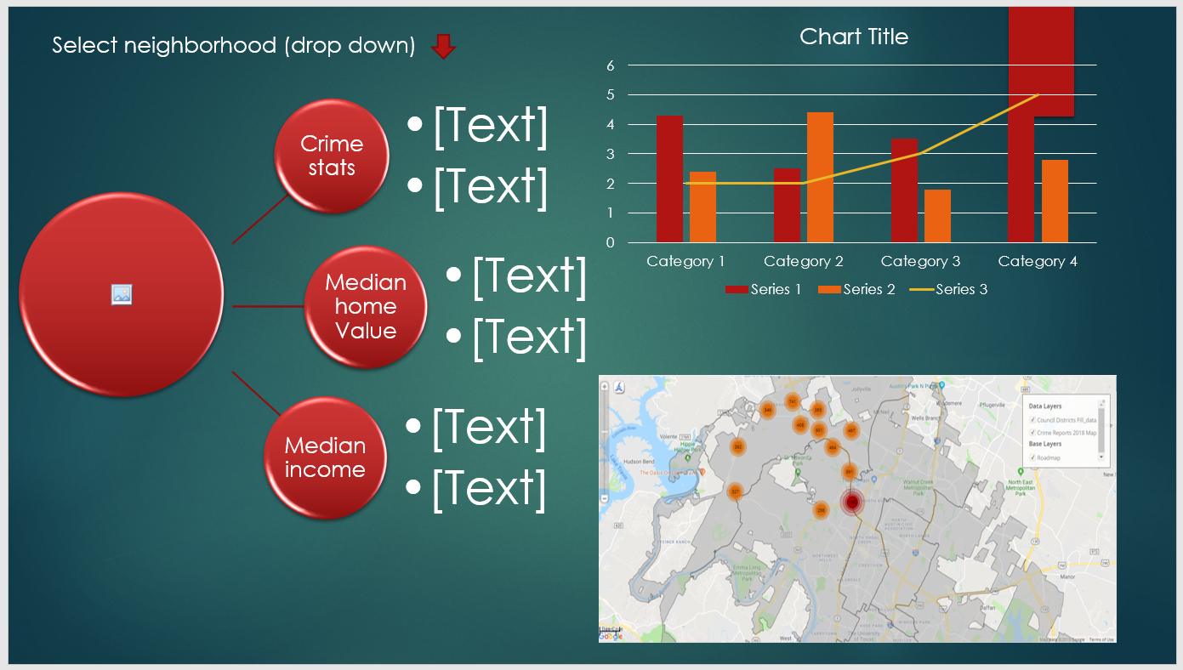

The project will be stored in our GitHub Repository.

